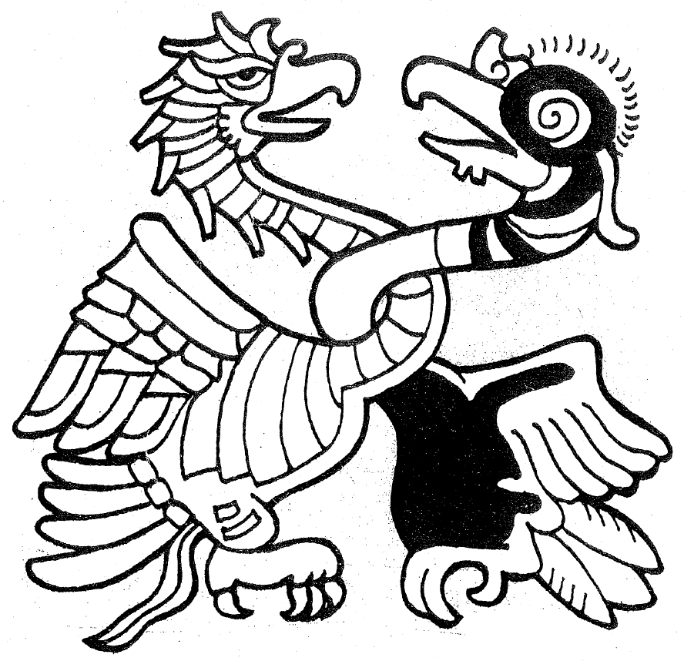



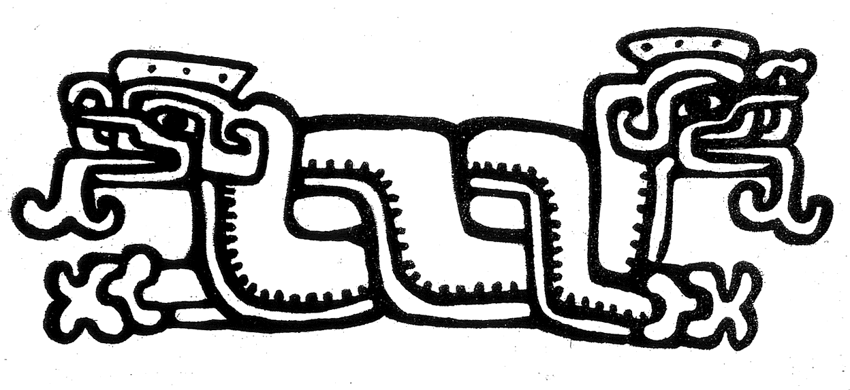

The Compact of Iximche

The Powers of Abya Yala

Realizing through the Power of Collective Memory, rooted in the millennial history of our coexistence on our continent Abya Yala, sharing in the blessings of Tonantzin our sacred mother Earth and the natural world of our territories;

Present now before the world with the Power of Collective Consciousness of our Pueblos and Nations of the entire continent gathered at this time in the III Continental Indigenous Summit Abya Yala, and

Acting with the Power of Will as a continental liberation movement of Abya Yala to decolonize our Pueblos, Nations, territories and cultures;

We make offering of our word, of our hearts, and of our strength as Izkalotlan Pueblo to fulfill the mutual obligations assumed and reaffirmed ceremonially by the Compact of Iximche as brothers and sisters of Abya Yala, in spiritual alliance under the Continental Confederation of the Eagle and Condor, in accord with our respective traditions and customs as Nican Tlacah, the Indigenous Pueblos and Nations of Abya Yala.

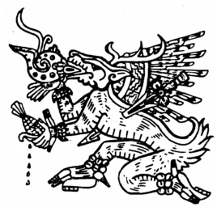
Tlahtokan Nahuacalli
Izkalotlan, Aztlan

*******

Proclamation Izkalotekah
Presented to the
III Continental Summit of Indigenous Pueblos and Nations of Abya Yala,
During the ceremony of reaffirmation of the
Treaty of Teotihuacan (First Continental Indigenous Summit, Teotihuacan México 2000)
By means of the Compact of Iximche

NAHUACALLI
Embajada de los Pueblos Indígenas
Izkalotlan, Aztlan
Email: chantlaca@aol.com
www.tonatierra.org

